All Staff Development (SD) grants will be issued through an Event Notification Memo. This memo will include:
- Specifics on how funds may be used, including any expenses that do not qualify for reimbursement.
- An event number, event title, start and end date of event, location of event, amount of award and possibly a list of approved travelers.
- For events funded through federal awards, the federal awarding entity, the CFDA number, the Federal Award Identification Number (FAIN) and the federal award date.
Memos will be sent via email to the Business Manager listed for the grantee.
Grantees are expected to book travel through the grantees travel procedures and submit for reimbursement to DEED. Requests for reimbursement of SD grants should occur
- 30 – days after the end of each quarter, Oct. 30, Jan 30, April 30 & July 30
OR
- After all travel for the specific activity is completed and expensed by the grantee.
Submissions for grant reimbursements are done through the DEED Staff Development form.
Grantees must submit one form per traveler per event. Required fields include:
- Submitter First Name
- Submitter Last Name
- Submitter Email
- School District Name (select from picklist) 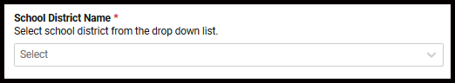
- Traveler’s First Name
- Traveler’s Last Name
- Travel Begin Date
- Travel End Date
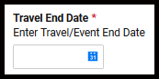
- Event Number (select one radio button – this must correspond to the event number in the Event Notification Memo.)
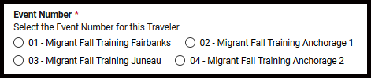
- Total Cost for Traveler
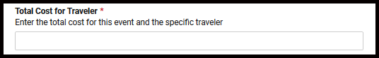
- Final Submission? (select yes or no radio button)
- File Attachments, an attachment of back up is required. Backup is expected to be source documents which support the total reimbursement request. This can be a ledger report. Files can be dragged and dropped. It is recognized that one file might provide the backup for several reimbursement submissions.
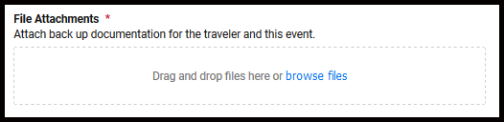
- Comments (optional field) Add any information you feel necessary. 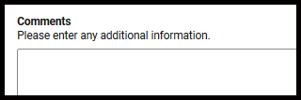
- Grantees can have a copy of the submission sent to them with this checkbox. An email address is required for a copy of the submission.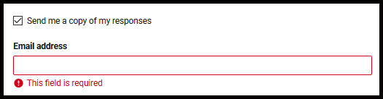
- Submit. When all required fields are complete, select the Submit button.
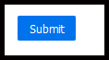
If a confirmation email has been requested, it will provide documentation of all information submitted.

- Conformation email
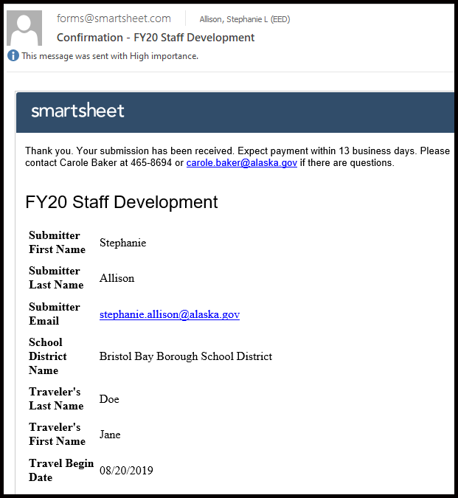
Any questions regarding reimbursement should be directed to SD Grant Administrator Alicia Hughes-Skandijs, alicia.hughes-skandijs@alaska.gov 907-465-8717

